https://www.surveygizmo.com/s3/5585162/MICHIGAN-LTCF-REPORTING-REGISTRATION
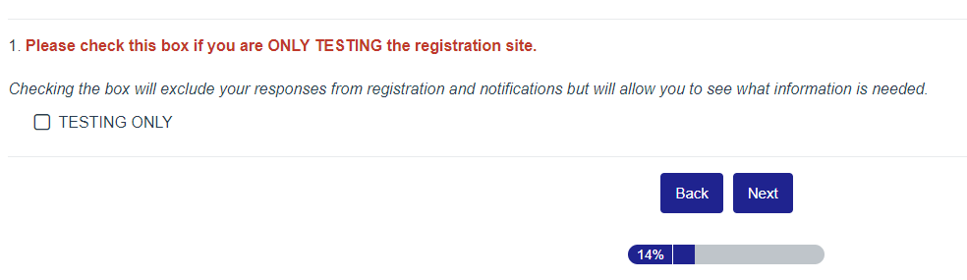
Select “TESTING ONLY” if you need to look around to see what information to have ready. Make sure that you don’t check “TESTING ONLY” when ready to sign up, or your entry won’t be processed.

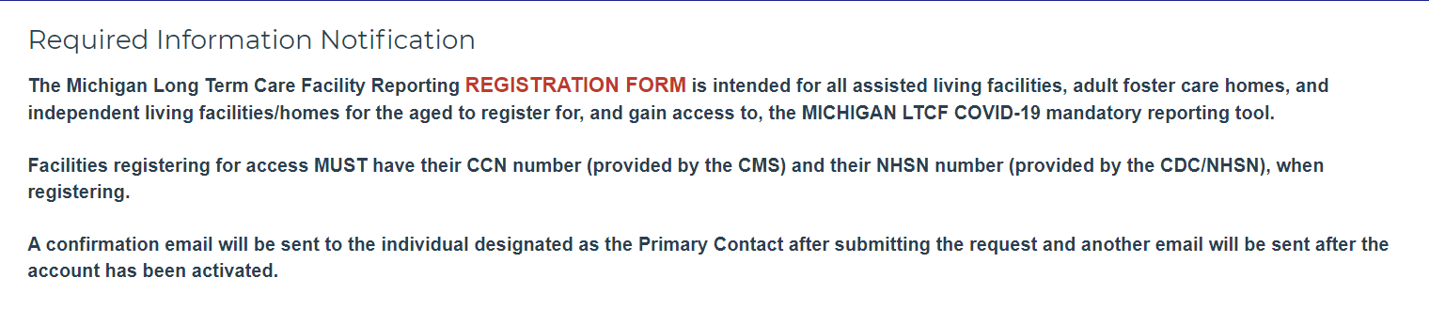
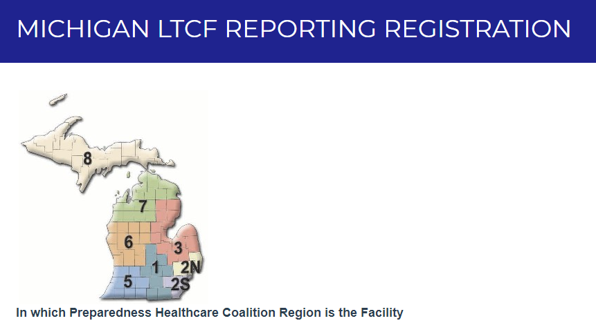
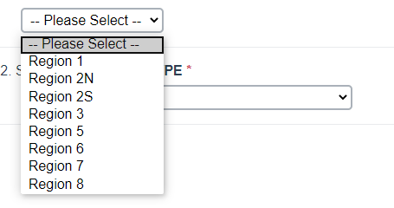
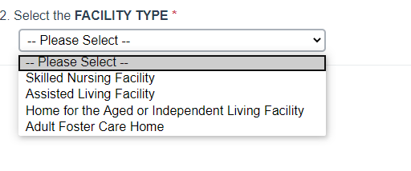
Skilled Nursing Facilities will be rerouted to the EMResource Registration Page.
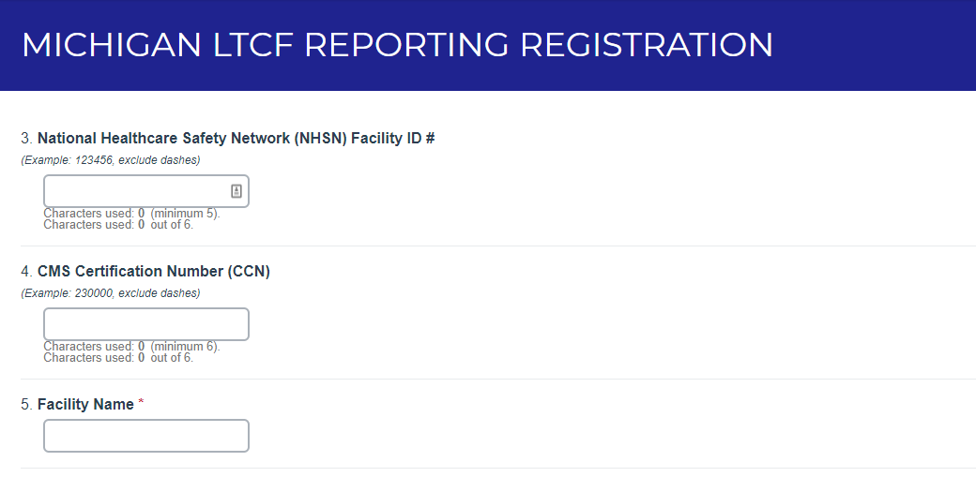
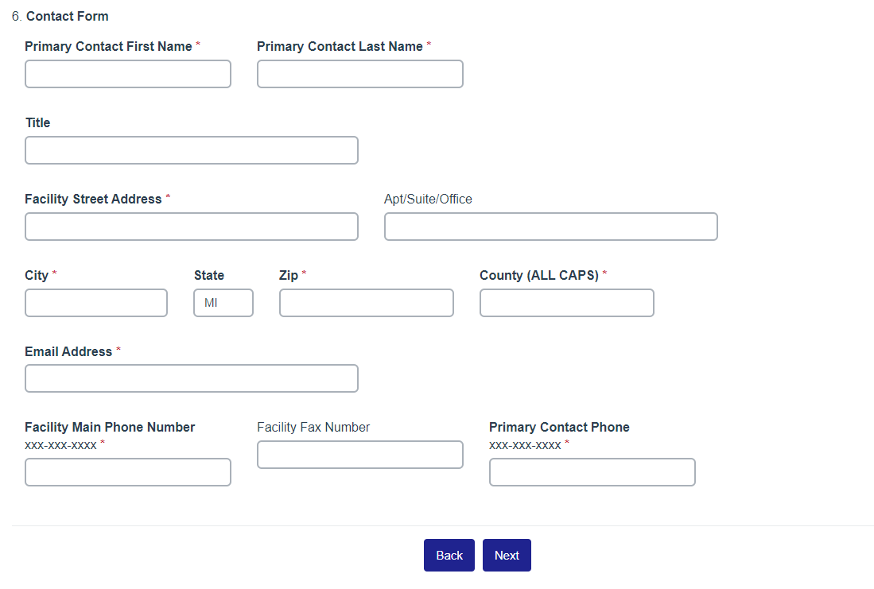

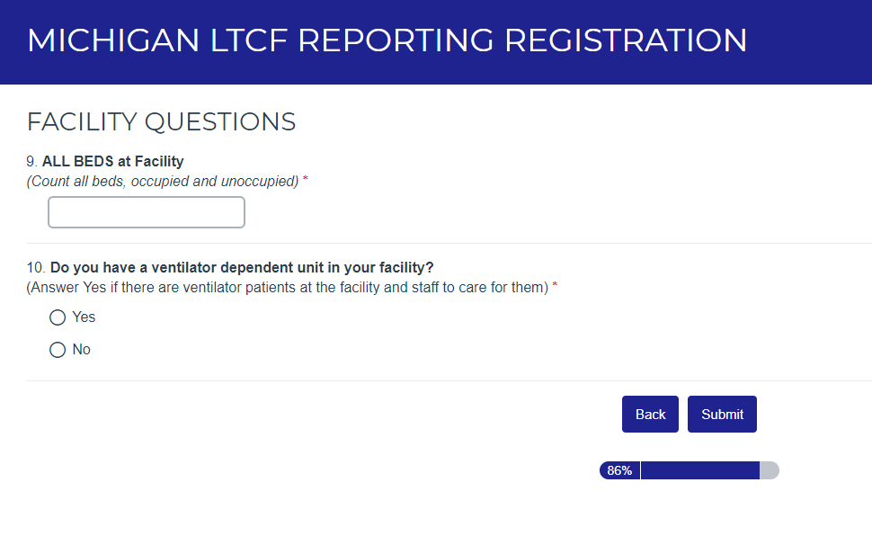
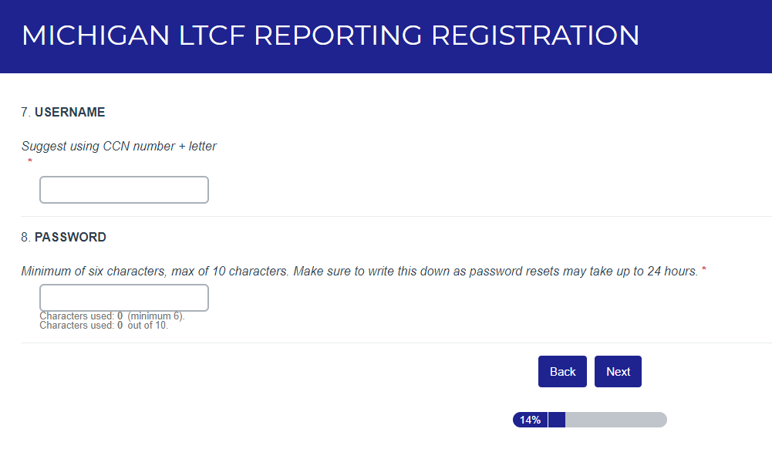

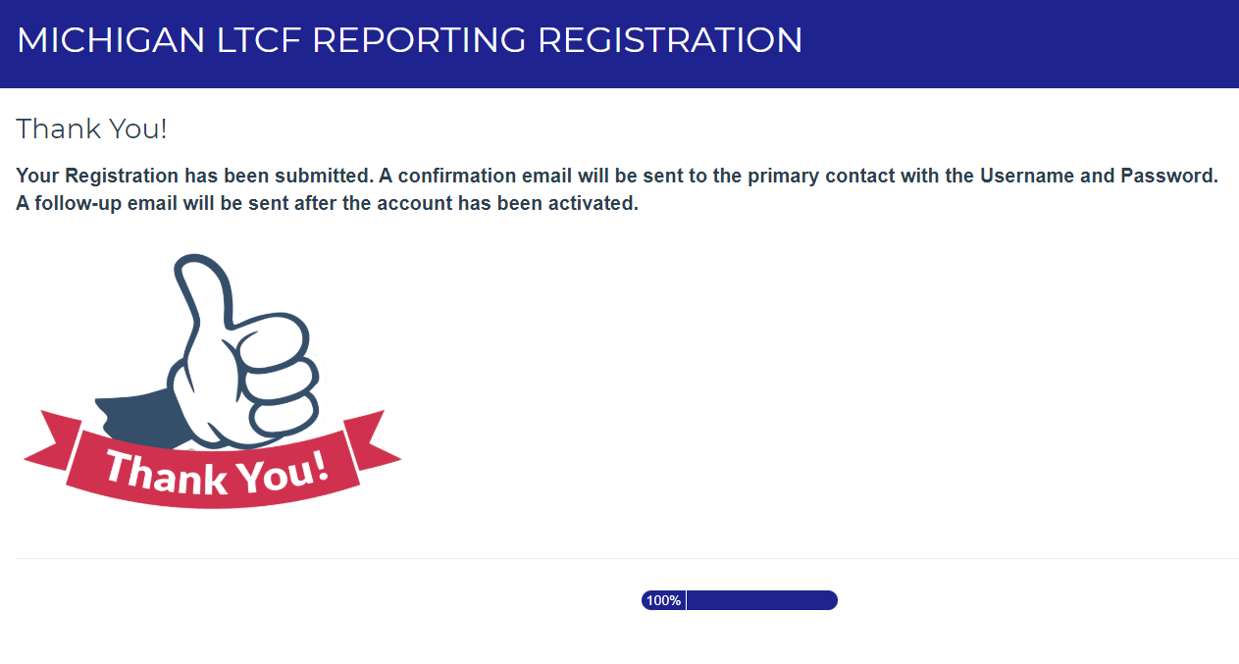
Following submission of the Registration Form, an email will be sent to the primary contact email entered on the form, along with the Username and Password selected.
Registration is expected to take 1 business day if completed on a workday. Fridays after 2PM until Monday at 8AM will be completed on Monday.
Access to the Reporting site link will be provided in the notification email.
HINT:
SAVE THIS LINK TO YOUR DESKTOP > https://www.surveygizmo.com/s3/5582391/f991ad2bfcbc

To support Michigan’s response to the COVID-19 pandemic, all long-term care facilities must report on specific data elements that have been identified by the Centers for Disease Control and Prevention (CDC) and the Michigan Department of Health and Human Services (MDHHS). Survey Gizmo should be completed for all long-term care facilities that are not skilled nursing facilities. Skilled nursing facilities must report in EMResource.
Failure to submit complete data according to requirements can result in both state compliance actions.
Reporting period: Seven-day period (Monday - Sunday) ending at Midnight (0000 HRS) the day of reporting
Example: When submitting data by noon (1200 HRs) on Monday, May 25, 2020, the facility will provide data collected from Monday, May 18, 2020 at 12:01am (0001 HRS) to Monday, May 25, 2020 at 12:00am (0000 HRS).
Reporting submission requirement: Weekly, Monday at noon (1200HRS)
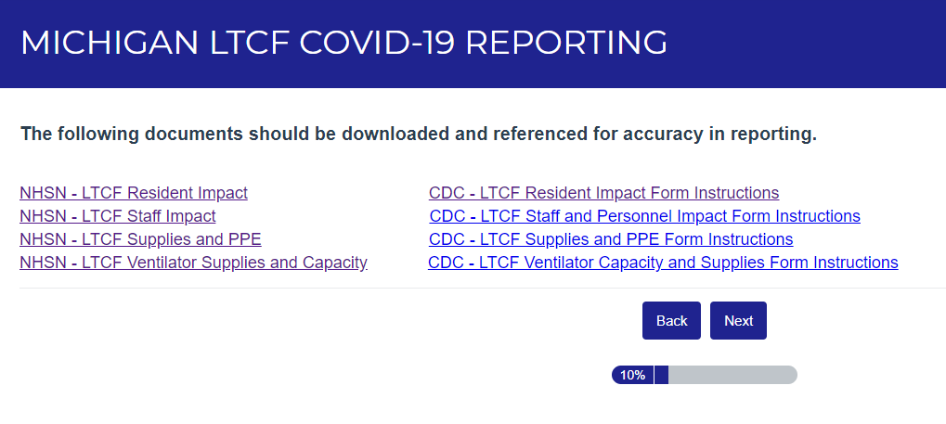

The titles and definitions are not always intuitive, so all CDC Definitions should be downloaded and used for reference when entering data until you become familiar with the data collected. The NHSN Forms are helpful for collecting the information prior to entry into the system.

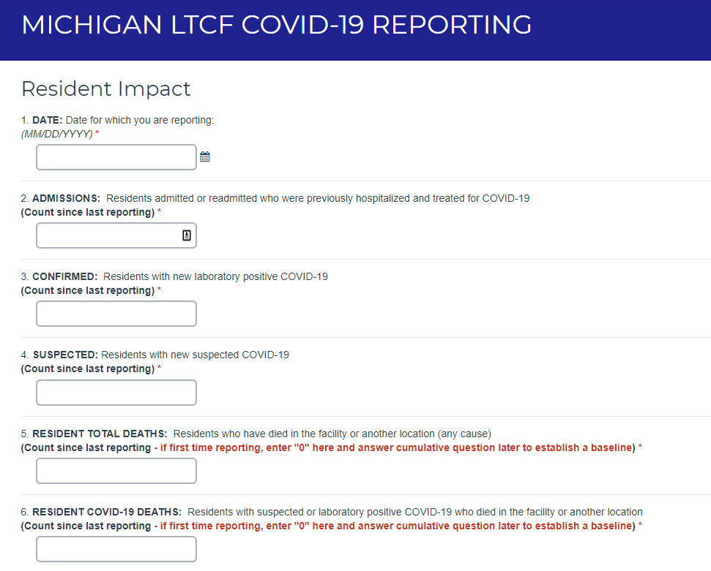

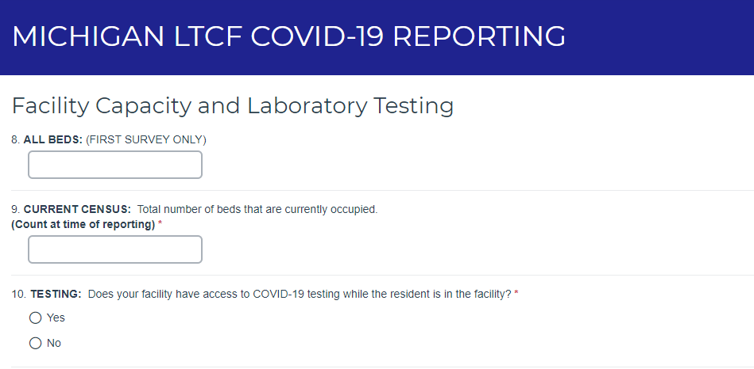

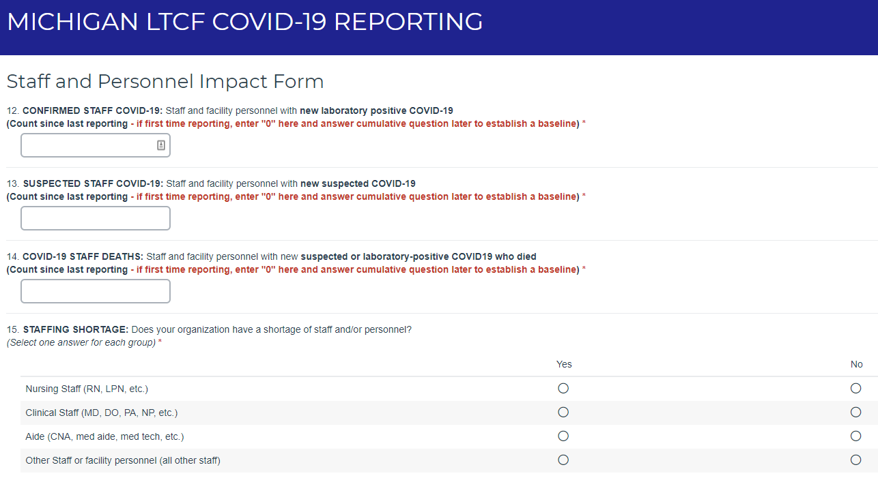

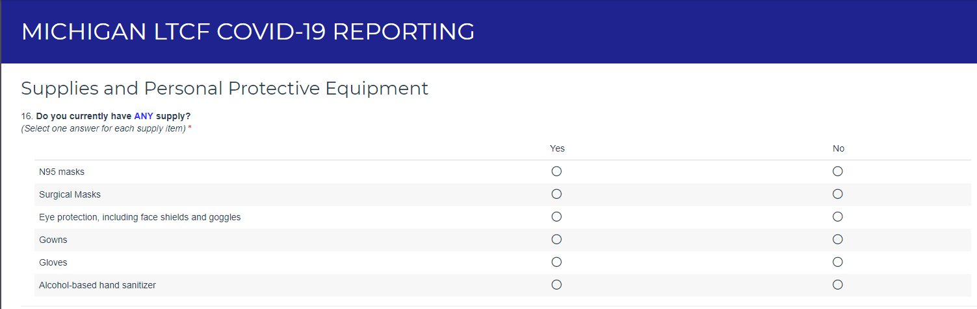
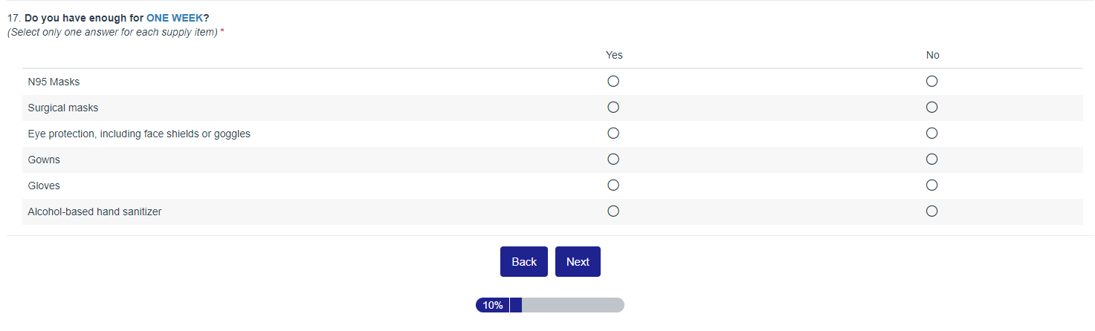

A “Yes” answer in the “Any Supply” section will prompt a dropdown question asking about having “enough for ONE WEEK”.

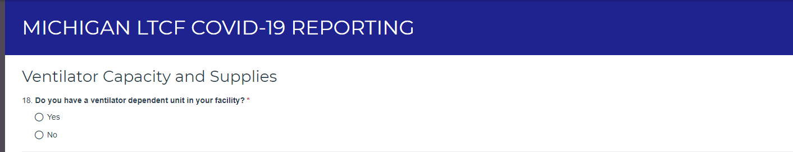
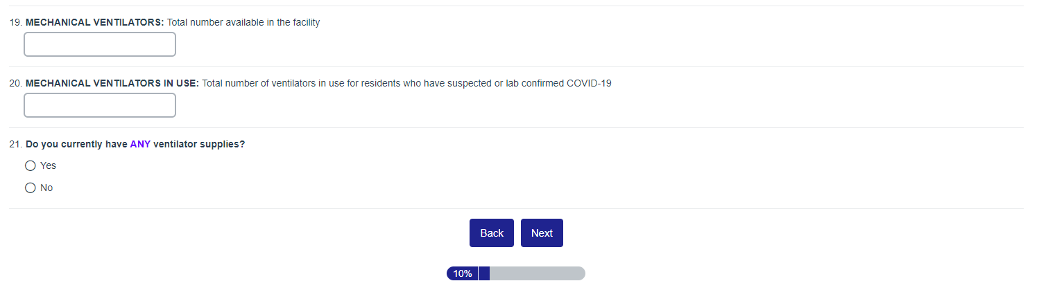

Ventilator Capacity and Supplies will be auto filled based on information provided in the registration form. Most will not see the ventilator counts and supply questions.
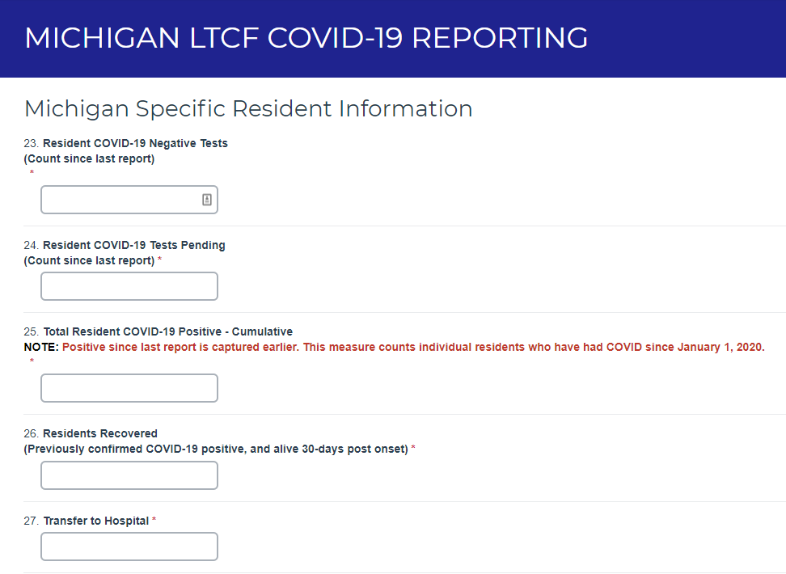
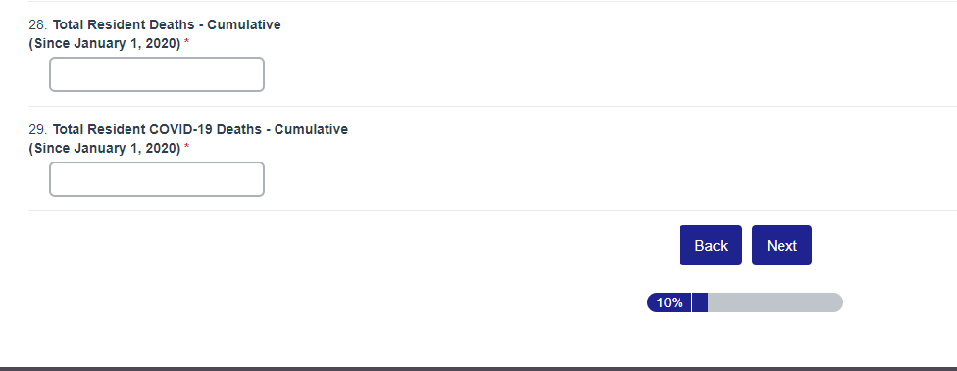

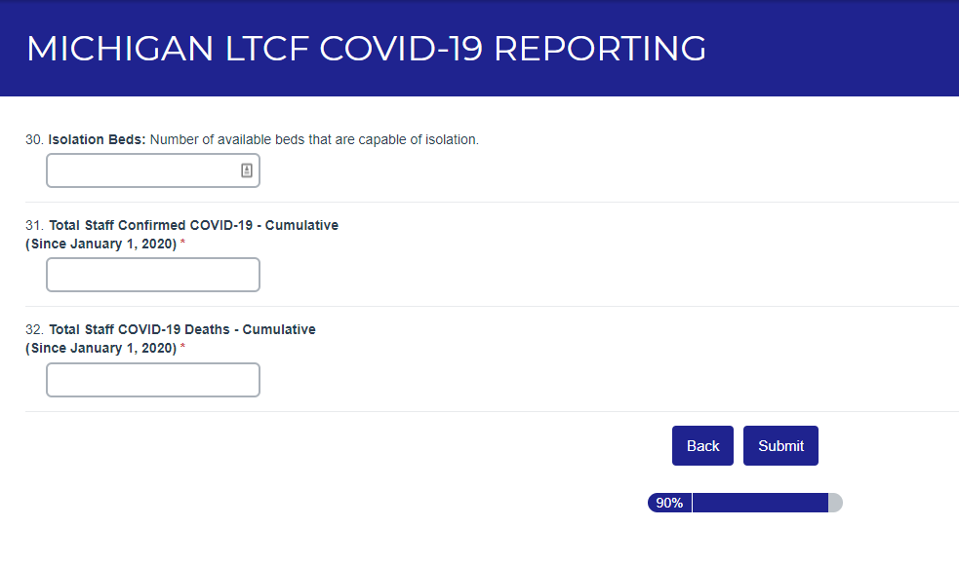
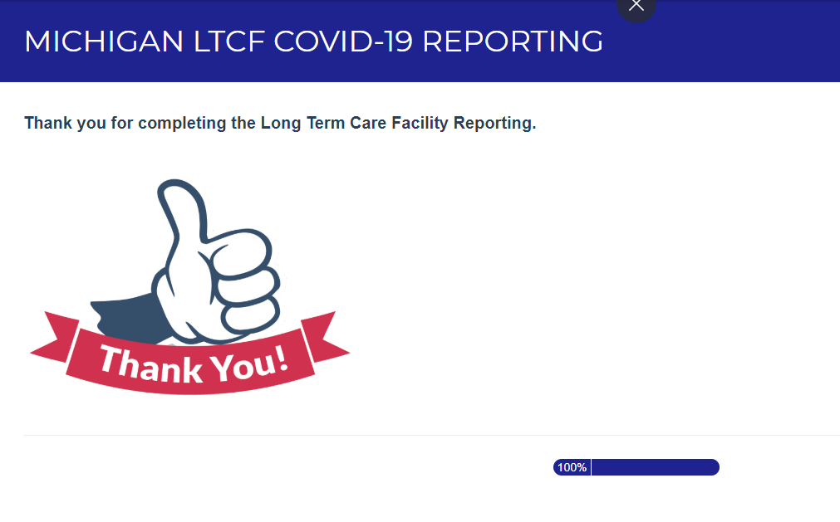
Once Submitted, the Primary Contact set up in the Registration Form will receive a confirmation email for the submission.

